|  |
| --- |
| IFMR RURAL FINANCE |
| ACH PDC Process |
|  |
| **Karthikeyan. V | IFMR Rural Finance** |
| **8/10/2016** |

Contents

1. Process Diagram 4

2. Stage definition 6

3. Stage-role access 8

2 ACH Registration 9

2.1 UI specification 9

2.2 Screenshot 9

2.3 Functional requirements 10

2.4 Uploads 10

2.5 Downloads 10

2.6 Reports 11

3 PDC Registration 12

3.1 UI specification 12

3.2 Screenshot 13

3.3 Functional requirements 14

3.4 Uploads 14

3.5 Downloads 14

3.6 Reports 14

4 ACH Submission 15

4.1 UI specification 15

4.2 Screenshot 15

4.3 Functional requirement 15

4.4 Uploads 15

4.5 Downloads 15

4.6 Reports 16

5 ACH MANDATE STATUS UPDATE 17

5.1 UI specification 17

5.2 Screenshot 17

5.3 Functional requirement 17

5.4 Uploads 17

5.5 Downloads 17

5.6 Reports 18

6 ACH Clearing - Collection 19

6.1 UI specification 19

6.2 Screenshot 19

6.3 Functional requirement 19

6.4 Uploads 19

6.5 Downloads 20

6.6 Reports 20

7 PDC Clearing - Collection 20

7.1 UI specification 20

7.2 Screenshot 20

7.3 Functional requirement 21

7.4 Uploads 21

7.5 Downloads 21

7.6 Reports 21

8 PDC Status maintenance 22

8.1 UI specification 22

8.2 Screenshot 22

8.3 Functional requirement 22

8.4 Downloads 22

8.5 Reports 22

# Process Diagram

ACH PDC REGISTARTION FLOW



ACH PDC Collection Process flow



# Stage definition

|  |  |
| --- | --- |
| **Stage** | **Description** |
| Registration of ACH | In this stage ACH details will be captured, - The status of the loan will be sent to bank for registration  . |
| Submission to bank | Download the excel with ACH details pending for registration - The status of the loan will remain as sent to bank for registration |
| Updating of ACH status | Once bank gives the details same is uploaded back in the system – Status will be either approved by bank/ rejected by bank. .If ACH is approved, all the normal PDC's collected for that particular loan will get cancelled from the system.  Repayment Mode should be changed to ACH or else resend to the MIS team for edition of the ACH data. |
| PDC details capture | This stage will capture all the PDC details and Type of PDC Security PDC or Normal PDC |
| ACH Clearing process | A batch file is processed with details of ACH based on the demand on that particular day. This demand excel will be sent with Covering letter to bank. All the Accounts due for the day should be shown in the grid. Batch files details stored in the system.  **Marking transaction as Paid** - On the same day all the accounts are uploaded as status marked as paid and the accounting entries are posted.  **Status Upload-** After 1 day or 2 day, the bounced and under clearance cases with reasons will only be uploaded as a batch,  If it’s under clearance, system needs a flag to identify, but no reversal of accounting entries.  If its bounced, then accounting entry will get reversed  Penalty and bounce will be calculated from the due date  For the bounced and not cleared cases it will go into the bounce queue and will follow collection process. |
| PDC Clearing process | In this stage a batch file is processed with details of PDCs based on the demand on that particular day. This demand excel will be sent to bank. And on the same day upload the data with status as Sent to bank, mark all transaction as paid.  **Status Upload-** After 1 day or 2 day, the bounced and under clearance cases with reasons will only be uploaded as a batch,  If it’s under clearance, system needs a flag to identify, but no reversal of accounting entries.  If its bounced, then accounting entry will get reversed  Penalty and bounce will be calculated from the due date  For the bounced and not cleared cases it will go into the bounce queue and will follow collection process. |
| PDC Status Maintenance | If a particular cheque is cancelled due to some reasons, then in the system, should allow to capture the cheque cancelled reasons and those cheque number should not be reflected in the demand collection |

# Stage-role access

|  |  |
| --- | --- |
| **Stage** | **Applicable Role** |
| ACH registration and Updating | MIS Team |
| PDC Details capturing | MIS Team |
| ACH Clearing Process | MIS Team |
| PDC Clearing Process | MIS Team |
| PDC Status maintaince | MIS Team |

# ACH Registration

This screen will be used to capture the ACH registration details.

## UI specification

**ACH Tab**

|  |  |  |  |  |  |
| --- | --- | --- | --- | --- | --- |
| **Field Name** | **Section** | **Data Type** | **Attribute** | **Validations/Restrictions** | **Population logic** |
| **Loan Account Number** | Loan Details | String | Read | - | Auto |
| **Branch Name** | Loan Details | String | Read | - | - |
| **Entity Name** | Loan Details | String | Read | - | - |
| **Applicant Name** | Loan Details | String | Read | - | - |
| **Co Applicant Name** | Loan Details | String | Read | - | - |
| **Frequency** | Loan Details | String | Read-Write |  |  |
| **Account Holder Name** | ACH Details | String | Read-Write | - | - |
| **Account type** | ACH Details | String | Read-Write |  |  |
| **Legal Account Number** | ACH Details | String | Read-Write |  |  |
| **IFSC Code** | ACH Details | String | Read-Write |  |  |
| **Bank Name & Branch Name** | ACH Details | String | Read |  |  |
| **Upto Maximum Amount** | ACH Details | Number | Read-Write |  |  |
| **Start Date** | ACH Details | Date | Read-Write |  |  |
| **End Date** | ACH Details | Date | Read-Write |  |  |
| **Mobile Phone** | ACH Details | String | Read-Write |  |  |
| **E-Mail** | ACH Details | String | Read-Write |  |  |

## Screenshot

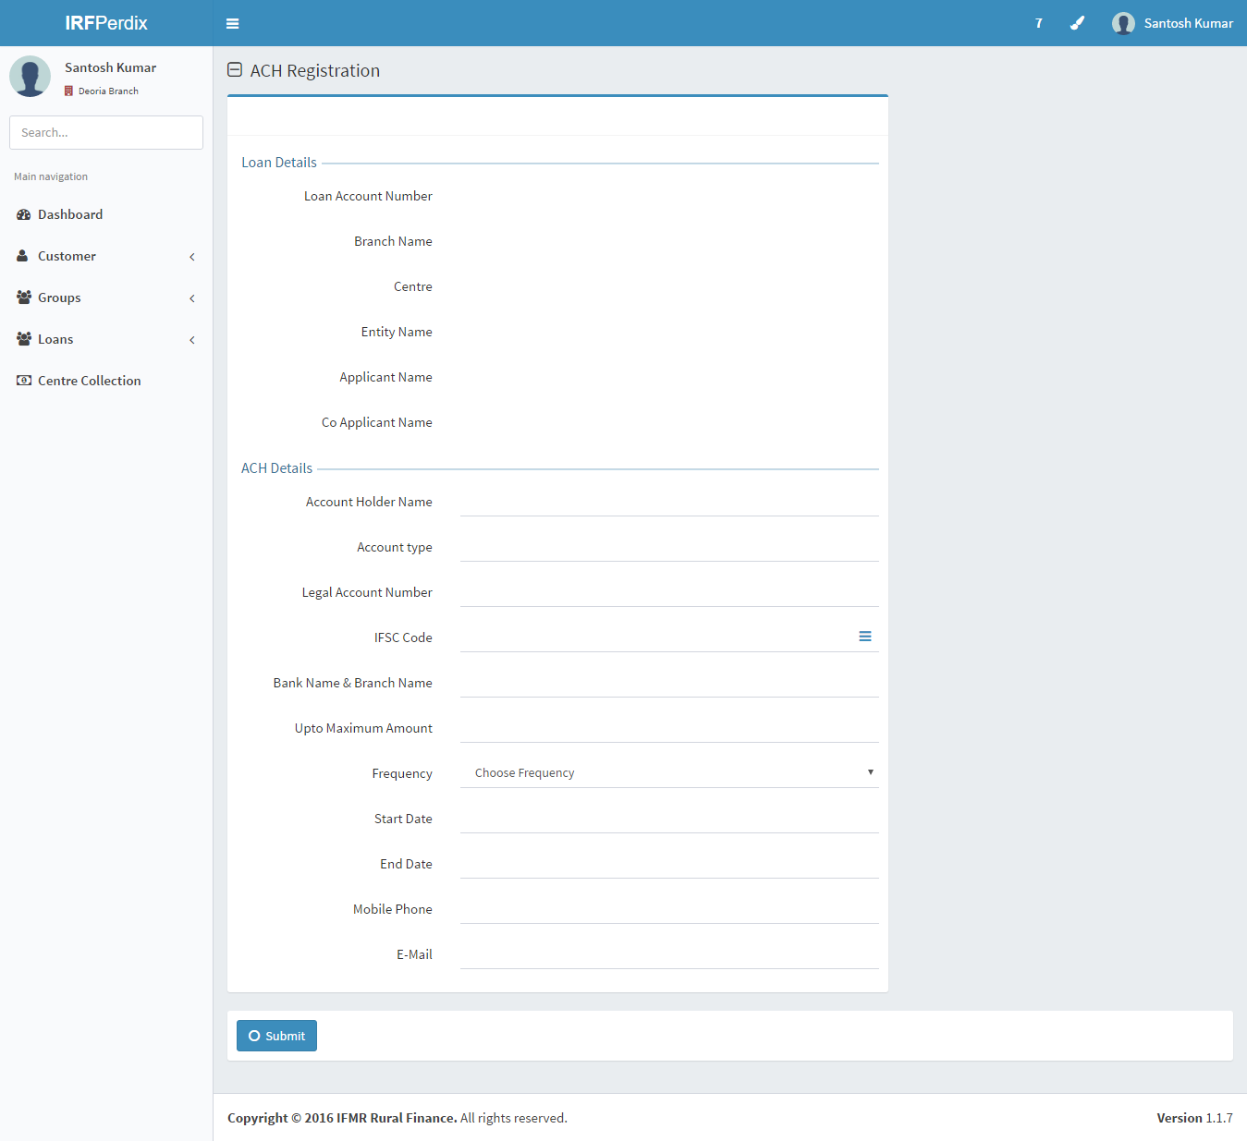

## Functional requirements

**Actor: MIS TEAM**

* 1. This screen lists all ACH registration fields to be captured at the time of disbursement.

## Uploads

NA

## Downloads

NA

## Reports

NA

# PDC Registration

This screen will be used to capture the PDC registration details.

## UI specification

**PDC Tab**

|  |  |  |  |  |  |
| --- | --- | --- | --- | --- | --- |
| **Field Name** | **Section** | **Data Type** | **Attribute** | **Validations/Restrictions** | **Population logic** |
| Loan Account Number | Loan Details | String | Read | - | Auto |
| Branch Name | Loan Details | String | Read | - | - |
| Centre Name | Loan Details | String | Read | - | - |
| Entity Name | Loan Details | String | Read | - | - |
| Applicant Name | Loan Details | String | Read | - | - |
| CoApplicant Name | Loan Details | String | Read | - | - |
| First Installment Date | PDC Details | Date | Read-Write | - | - |
| Starting Check Number | PDC Details | String | Read-Write | - | Multiple Entry |
| Number of Leaves | PDC Details | Number | Read-Write |  | Multiple Entry |
| Installment Amount | PDC Details | Number | Read-Write |  | Multiple Entry |
| IFSC Code | PDC Details | String | Read-Write |  | Multiple Entry |
| Bank Name | PDC Details | String | Read |  | Multiple Entry |
| Branch Name | PDC Details | Number | Read-Write |  | Multiple Entry |
| Security Check Number | Security Check | String | Read-Write | - | - |
| IFSC Code | Security Check | String | Read-Write |  | - |
| Bank Name | Security Check | String | Read |  | - |
| Branch Name | Security Check | Number | Read-Write |  | - |

## Screenshot

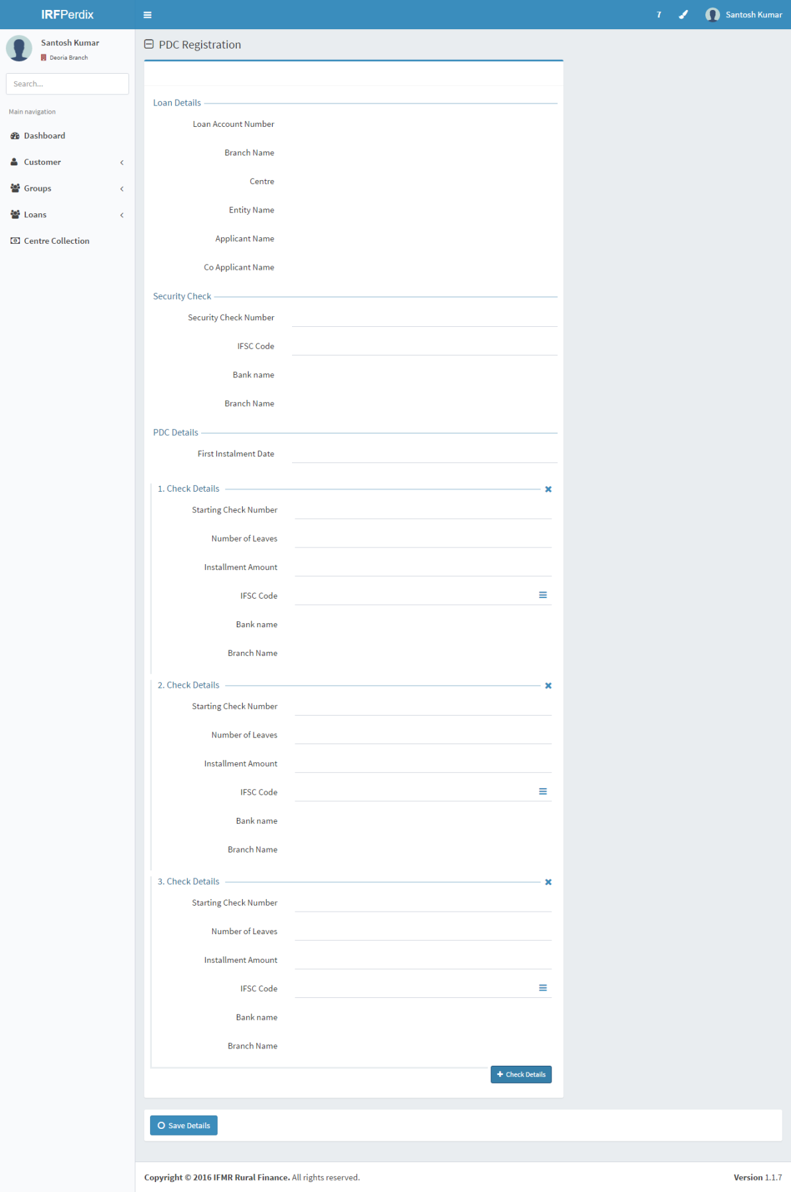

## Functional requirements

**Actor: MIS TEAM**

* 1. This screen lists all PDC registration fields to be captured at the time of disbursement.
  2. PDC includes Security PDC and/or Normal PDC to be captured.

## Uploads

NA

## Downloads

NA

## Reports

NA

# ACH Submission

## UI specification

|  |  |  |  |  |  |
| --- | --- | --- | --- | --- | --- |
| Field Name | Section | Data Type | Attribute | Validations/ Restrictions | Population logic |
| **Choose File** | ACH Registration | Button | Read-Write |  | To pick the file |
| **Upload** | ACH Registration | Button | Read-Write |  | To upload the file |

## Screenshot

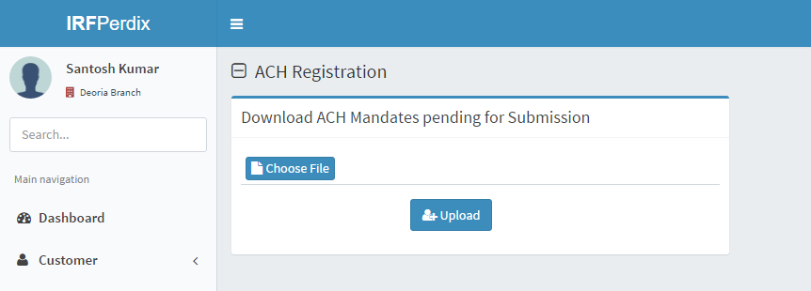

## Functional requirement

**Actor: MIS Team**

1. Download the excel with ACH details which are pending for registration
2. Update the Status as - Sent to bank for registration

## Uploads

NA

## Downloads

1. Download the excel with ACH details which are pending for registration

## Reports

NA

# ACH MANDATE STATUS UPDATE

## UI specification

|  |  |  |  |  |  |
| --- | --- | --- | --- | --- | --- |
| **Choose File** | ACH Registration | Button | Read-Write |  | To pick the file |
| **Upload** | ACH Registration | Button | Read-Write |  | To upload the file |

## Screenshot

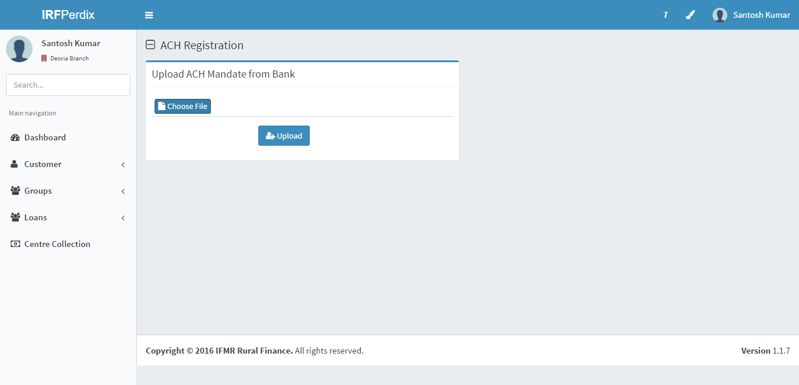

## Functional requirement

**Actor: MIS Team**

1. Once bank gives the details same is uploaded back in the system – Status will be either approved by bank/ rejected by bank.
2. If ACH is approved, all the normal PDC's collected for that particular loan will get cancelled from the system.
3. Repayment Mode should be changed to ACH.

## Uploads

1. Upload the excel with ACH details

## Downloads

N.A

## Reports

NA

# ACH Clearing - Collection

## UI specification

|  |  |  |  |  |  |
| --- | --- | --- | --- | --- | --- |
| Field Name | Section | Data Type | Attribute | Validations/ Restrictions | Population logic |
| Installment Date | ACH Demands | Date | - | - | Demand Due Date |
|  |  |  |  |  |  |
|  |  |  |  |  |  |
|  |  |  |  |  |  |

## Screenshot

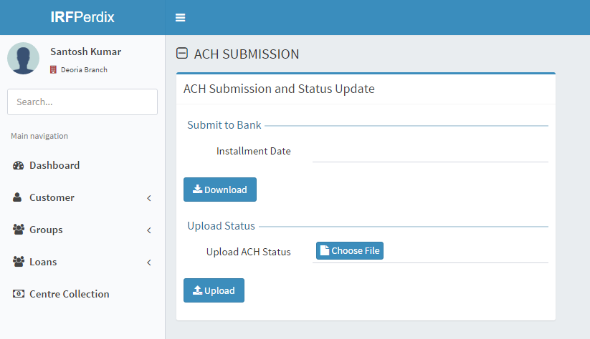

## Functional requirement

**Actor: MIS Team**

1. This screen will have option to download the demand due list with date criteria
2. This screen will have option to upload the status of the demands as received from Bank

## Uploads

N.A

## Downloads

N.A

## Reports

NA

# PDC Clearing - Collection

## UI specification

|  |  |  |  |  |  |
| --- | --- | --- | --- | --- | --- |
| Field Name | Section | Data Type | Attribute | Validations/ Restrictions | Population logic |
| Installment Date | PDC Demands | Date | - | - | Demand Due Date |
|  |  |  |  |  |  |
|  |  |  |  |  |  |
|  |  |  |  |  |  |

## Screenshot

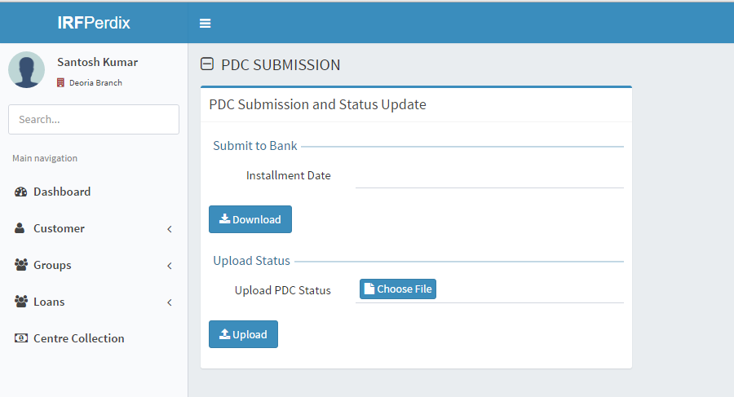

## Functional requirement

**Actor: MIS Team**

1. This screen will have option to download the demand due list with date criteria
2. This screen will have the option to upload the PDC repayment status from Bank

## Uploads

N.A

## Downloads

N.A

## Reports

NA

# PDC Status maintenance

## UI specification

|  |  |  |  |  |  |
| --- | --- | --- | --- | --- | --- |
| Field Name | Section | Data Type | Attribute | Validations/ Restrictions | Population logic |
| Loan account No | PDC Status maintenance | Text | Write | - | Master to be maintained |
|  |  |  |  |  |  |

## Screenshot

To be prepared. Need clarification

## Functional requirement

**Actor: MIS Team**

1. If a particular cheque is cancelled due to some reasons, then in the system, A master table for PDC Status maintenance is maintained
2. Against the loan account number the same to be captured if the cheque is cancelled due to some reason.

|  |
| --- |
| Cheque Lost/Exchange |
| Cheque Returned |
| Signature Mismatch |
| Other Reason |

## Downloads

N.A

## Reports

NA